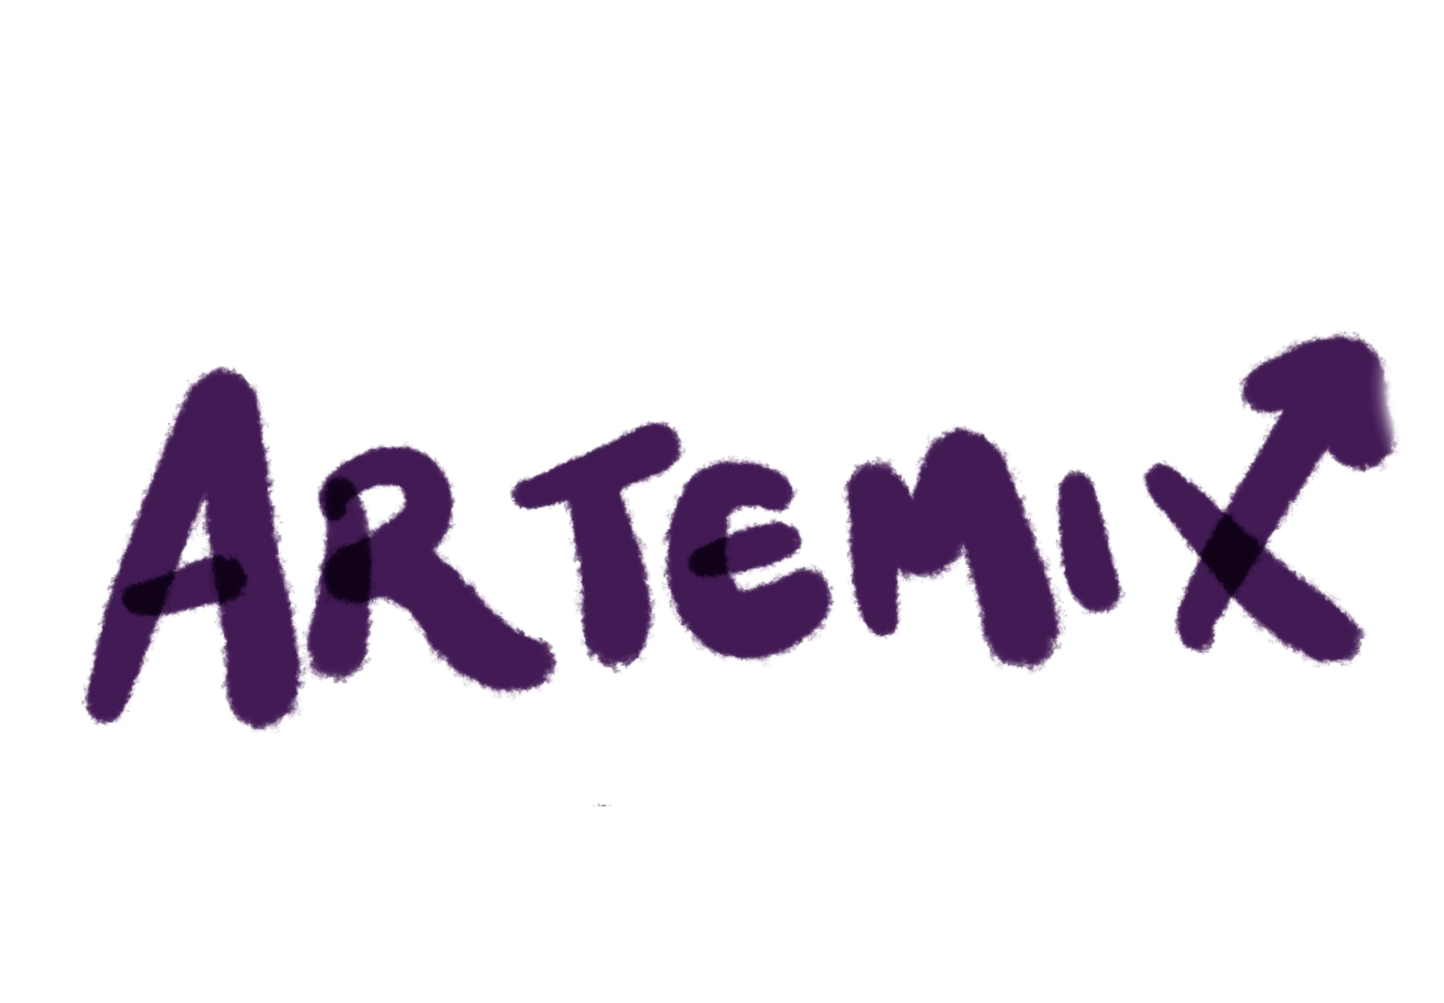

Final Report

Autumn 2023
Threads and Trends
Winnie C., Yutong Z., Georgia L., Kongmeng H.

Table of Contents:
Project Name & Value Proposition | 3
Team Members | 3
Problem & Solution Overview | 3
Needfinding | 4
POVs & Experience Prototypes | 6
Design Evolution | 11
Values in Design | 20
Final Prototype Implementation | 21
Reflection and Next Steps | 22

Project Name & Value Proposition

Project Name:
Artemix

Value Proposition:
Remixing the way you art.

Team Members
- Winnie Chen: Developer, Designer
- Yutong Zhang: Developer, Designer
- Georgia Limcaoco: Developer, Designer
- Kongmeng Her: Developer, Designer

Problem and Solution Overview

While creative collaboration is incredibly important to artists, some forms of art can be isolating by nature. After long periods of time alone painting or writing, artists can find it difficult to find supportive communities to share their creations with.

Artemix is an art-first platform that redefines how artists share, connect, and collaborate. We let a true passion for art drive our match-based platform, allowing for genuine connections and meaningful collaborations between users. Artemix is designed specifically for creative professionals and dedicated hobbyists. By anonymizing artists, we ensure unbiased appreciation of artwork, recommending connections only after a user consistently admires a particular artist's contributions.

Needfinding

Methodology:
We began with selecting artistic creatives as our target group for interviews. We reached out through our personal connections and networks, being conscious of interviewing people from various backgrounds, ages, and gender. Our goal was to find interviewees who dedicated a large portion of their time to their artistic work, as well as diversifying our choices by interviewing only one person from an artistic field. We were most curious about isolated artists and set that as our extreme users. Over the course of five interviews, we talked to a vocal artist, a dancer, a jewelry designer, a graphic artist, and a writer, setting the writer and jewelry designer as our extreme users as they were the most isolated. Most of these interviews were conducted in person, with Zoom as a resort if in-person was not possible. At least two members of our team were at each interview.
The interviews began with an introduction, an ask for consent, and general biographical questions. This was then followed by detailed questions about themselves in relation to their artistic work. A script was used for a general outline, but our conversations flowed freely as we were more interested in their personal stories, ideas, and thoughts about their work. Some of the questions asked are as follows:

- What does your day-to-day work look like?
- How do you find inspiration when you’re feeling stuck?
- What aspects of the creative process do you find most difficult?
- What types of collaborative work have you conducted, if any?

Insights & Synthesis:

After each interview, we synthesized our findings through the use of empathy maps. We created one for each person as it helped us organize and digest each interview. From these structures we were able to gain essential insights.

First, we learned that different artforms engage with communities very differently. Our vocal artist and dancer (performing arts) did not lack an accessible community. On the other hand, our graphic designer and jewelry designer confirmed what we assumed about isolating artforms: there’s a lack of a meaningful community to engage in. While our vocal artist has an easier access to an artistic community, there was still a disconnect that distanced her. Our dancer also described distinguishing relationships to the artform when dancing with others and dancing individually. There existed conflicting reasons for communal performance and individual satisfaction. Surprisingly enough, our writer did not feel a lack of connection to an artistic community. He said “It doesn’t feel isolating because you’re communing with your imagination, the people you’re writing about, and the authors you admire.” Overall, we saw the general lack of meaningful connections and communities as a theme across most of our interviews.

Second, we saw that collaborative work needs to be conceived as comfortable and valuable for artists to opt in. Our jewelry designer saw most collaborations as useless and collaborations as a sense of validation instead. This was heavily tied to poor past experiences. The graphic designer also echoed similar sentiments by saying “Having friends or peers that you feel safe showing or talking about the process”. For her, friends and peers was the space of comfort necessary for meaningful conversations and contributions to her work. Similarly, our dancer expressed that his individualistic dancing is rarely shown in performance, but mainly to friends. This sense of comfort was vital for these artists when working with others.

Lastly, artists see collaboration as a means to self-understanding. Our dancer finds immense joy in his individual dancing because it allows him to fulfill his need for self-expression. Our writer also saw collaboration in a different light, where his literary work is a part of a larger conversation involving work from other writers. To this he says, “To a certain extent, they’re always there. The bookcase is always behind me.” In that sense, he sees his work, a form of understanding his relationship to the world, to always be collaborating with other pieces of written work. Overall, all of these findings helped us focus on the multifaceted role that collaboration plays in the work process of artists as we continued on with the next steps of the design process.

POVS & Experience Prototypes

After our preliminary needfinding interviews, we created three “Point of Views” to delve deeper into the pain points of each of our individual interviewees and begin brainstorming possible game-changing solutions. As a group, we then brainstormed 10-15 “How Might We” statements per POV.

POV #1:
We met: Kangyi, a jewelry designer in London
We were surprised to realize: She doesn’t like collaborating with other artists in her domain.
We wondered if this means: She doesn’t feel supported or seen by other designers.
It would be game-changing to: Help her connect with other people in her artistic, cultural, and personal domains.

How Might We’s
- How might we make her friends like jewelry design?
- How might we reduce competition amongst designers?
- How might we make the designer community a supportive, safe space?
- How might we make artists in other domains care about/want to collaborate with jewelry design?
- How might we make her background more understandable to other artists?
- How might we make every artist understand her background and interest before talking with her?
- How might we remove other artists?
- How might we make her feel like the most valued jewelry designer in the world?
- How might we introduce her to other artists with a shared background/culture?
- How might we filter out negative commentary?
- How might we make criticism seem valuable?

POV #2:
We met: Ru, a vocal artist with a PhD in musicology living in the Bay Area.
We were surprised to realize: She has an app for artist collaboration but is hesitant to connect with artists on it.
We wondered if this means: She feels most online connections do not actually lead to collaboration.
It would be game-changing to: Ensure all her connections will lead to meaningful collaboration.

How Might We’s
- How might we make her feel more comfortable meeting new people?
- How might we filter out people who don’t want to collaborate after connecting?
- How might we make meeting people more casual?
- How might we maintain connections across community borders?
- How might we make other people reach out to her first?
- How might we encourage mutual friend introductions?
- How might we provide her with a smaller pool of more high-quality collaborators?
- How might we put her art out there?
- How might we only allow people with the same goals to connect with her?
- How might we increase her visibility in the area?

POV #3:
We met: Chali, an undergraduate Stanford student in a dance team as artistic director.
We were surprised to realize: He dances for different reasons when he is alone vs when he is with his team.
We wondered if this means: Dancing satisfies two different personal needs within him (emotional processing/self expression vs technical exploration/performance)
It would be game-changing to: Connect him with an audience that makes him feel seen in both ways.

How Might We’s
- How might we make audiences less judgmental?
- How might we make audiences invisible?
- How might we make technical exploration emotional?
- How might we connect him with other people who have the same needs as him?
- How might we change the standards of the dance community?
- How might we filter out people who don’t appreciate his self-expression from the audience?
- How might we make the audience like his best friend?
- How might we make him confident and comfortable to self express in front of audiences?
- How might we create more chances for him to explore and fulfill both sides / needs?
- How might we allow him to explore technically while dancing alone?

We took the top 9 highlighted HMW statements and combined them to come up with our three favorite HMWs across all POVs:
- How might we expose artists only to communities that would certainly value and interact with their art?
- How might we make audiences want to look into an artist’s background and interests?
- How might we maintain past artistic connections beyond physical limitations such as distance?
We then got back together and brainstormed possible solutions for each HMW, then chose our top 3.
Top 3 Chosen Solutions
- Match-based design where, after enough mutual likes of each others’ art, artists are connected to each other.
- Artists/users can rate commenters and their feedback, providing community-based vetting of audience members and weeding out haters or trolls.
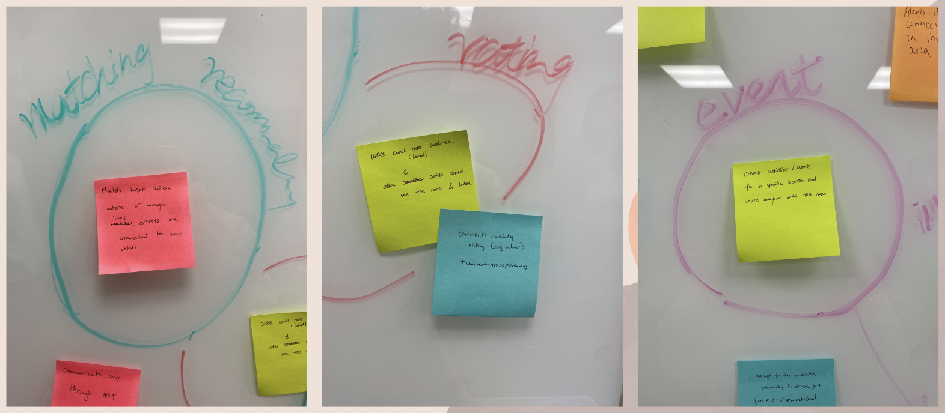
- Create activities/events for a specific location and invite anyone within this area.

We then constructed three Experience Prototypes to test the underlying assumptions in each solution. The prototypes were constructed as follows:
Experience Prototype #1:
Assumption: Artists will know whether or not they want to connect with another artist based on their art alone.
We created three fake artist profiles with five pieces of art each (all art from the same real artists to ensure consistency across the profile), then anonymized the art and shuffled the pieces on a slideshow presentation. We recruited a visual artist to participate in our experiment – Sreya H., an oil painter, sketch artist, and digital artist. We then had Sreya say whether or not she’d want to meet the artist of each anonymous piece. Then, we showed her the profiles disconnected from the art pieces and asked which person, based on reputation alone, she would want to collaborate with. Finally, we revealed which art belonged to which profile and asked her to rerank to see if seeing the art of a person would affect whether or not she wanted to meet with them.
We found that Sreya prioritized the art she liked over the artists’ reputation, switching her ranking when she realized that the profile she had ranked second had actually produced most of her favorite art despite not being as professionally acclaimed as one of the other profiles. We also found that she began giving reasons as to why she would want to meet with certain artists concerning their art, such as techniques she noticed and was curious about or strengths she saw in their works that she found herself weak in. We confirmed our assumption that an art-first approach works in matching artists to each other. Sreya did, however, state that she was not necessarily looking for collaborators as a visual artist – she would be more interested in chatting about inspiration and technique than in working with another artist on a piece.
Experience Prototype #2:
Assumption: Seeing a commenter’s credibility rating will make artists more willing to receive feedback.
We created ten fake comments, all ranging in content from very negative to very positive, then assigned each comment a credibility rating, ranking the person who allegedly commented it from least credible (such as a known troll) or most credible (such as a respected artist who has a history of positive engagement with the platform). We showed the anonymized comments to our participant Nathan, a bass player and involved on-campus musician, and asked how he felt about each one, then added the profile rankings on and asked if seeing these changed his feelings about the comments.
We found that Nathan immediately employed his own internal vetting system to the comments – he saw more specific comments as more valid and valuable, and naturally ignored the hateful non-specific comments. When profiles and ratings were made visible alongside the comments, he focused more on the commenter’s titles and backgrounds (we had assigned each of them a title such as ‘Beginner’ or ‘Professional Musician’) than the ratings they had been given as commenters, valuing the commenter’s identity first. He also questioned the ratings, as he did not know how many users had ranked these commenters and was therefore wary to trust them. This prototype debunked our assumption and we decided not to move forward with a commenter-ranking system.
Experience Prototype #3:
Assumption: People are more interested in in-person artistic events rather than online ones.
We created a map of campus and populated it with fake artistic events covering multiple domains from visual art to music to performances, then created a list of fake virtual events and presented both to a singer, Keeseok. We found that Keeseok only chose to go to in-person events, even if the event was not directly related to his artistic domain (music). He was not willing to go to any virtual events, even if they were strongly related to his domain and interest. Our assumption was confirmed, and we were surprised to see that Keeseok was even willing to explore other art forms and meet other artists from other domains at events as long as the event was in person.

Final Solution

Description
Artemix: a platform with an art-first approach to matching artists with potential collaborators through anonymization, encouraging unbiased appreciation and positive interactions.

Target Audience
Traditionally isolated artists such as visual artists (painters, graphic designers, photographers) and writers – specifically, professionals or long-time dedicated hobbyists.

Who Might Be Left Out
People who are visually impaired, non-visual artists such as musicians or singers, and more reserved artists/beginners who may not have many pieces of art created or who may be scared or hesitant to share their art online.

Ethical Implications
Echo chambers (filtering out possible critics, disabling comments prior to demonstrated interest, matching only similarly-minded artists)

Design Evolution

Tasks
- Simple Task: like a piece of artwork.
In order to match with other artists on Artemix, users must demonstrate enough interest in their artwork by liking a certain amount of a specific artist’s anonymized work. Additionally, all of a user’s liked art is saved on a tab in their profile for them to revisit for inspiration. This task is the building block of all other functionality on the platform and thus will be a user’s most frequent action. This requires a user to select a piece of art from their homepage and select the ‘Interested’ button.

- Moderate Task: comment on a piece of artwork.
To create supportive and collaborative artistic communities, artists need to be able to communicate with each other and interact with each others’ art in a positive, constructive manner. On Artemix, users can only comment on art they have demonstrated interest in, or liked. This is to ensure that any comments given are constructive and/or validating, filtering out needless hate from the beginning and connecting artists in a positive light. This task requires the user to like a piece of art (completing the simple task), type out a comment, and post it on the piece.

- Complex Task: schedule a meeting with another artist.
We hope to encourage our user base to eventually take the connections they create on the platform offline. Our scheduling feature hopefully encourages users to take the first digital steps towards an in-person meetup by lowering barriers to making plans. While we hope to make online connections more fruitful and positive on Artemix, creative partnerships are more likely to last and have a bigger impact in person as discovered through our needfinding stages, thus we wanted to build this aspect of collaboration into our platform. This task requires users to be matched with another artist, navigate to their profile, navigate to the scheduling tab on the profile, select a date and time, type out a meeting request, and click send.

Visualizations and Rationale

Lo-Fi Prototype & Initial Sketches

At the very start of our design process, we brainstormed and visualized various forms our solution could take on different platforms. Among our ideas were a VR headset experience, a mobile app, a desktop app, and a wearable app (think: Apple Watch). Our top two were the VR headset experience and the mobile app.

- VR headset experience
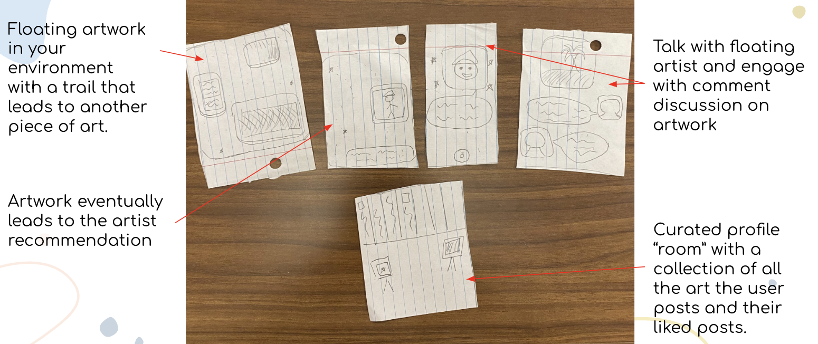

- Mobile app
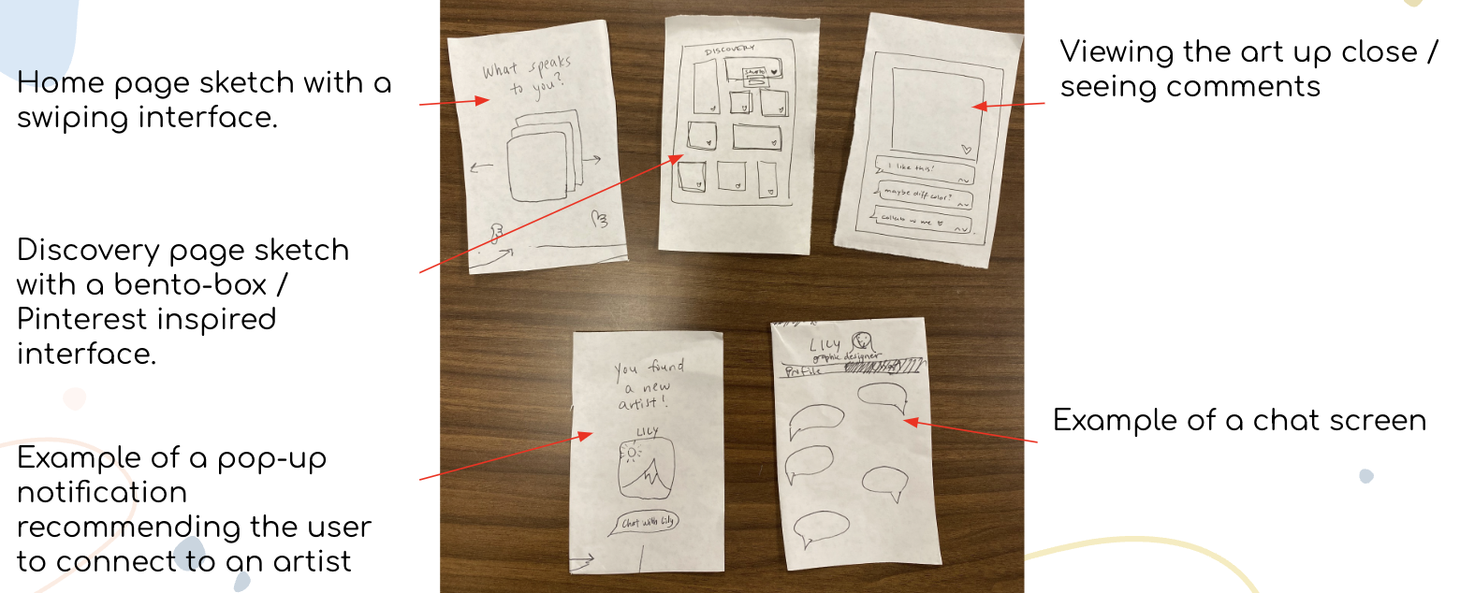

Evaluation Technique: Pros & Cons List
We made a pros and cons list of each interface design to choose one to move forward with. We liked that the VR headset offered users more immersive experiences in viewing art and collaborating with other artists. However, we found that the headset posed accessibility issues to our target users as not everyone has a VR headset, especially full-time artists, and that this may also pose a financial barrier as well as a proficiency gap as users may need to acclimate to VR headset controls first. We liked that our mobile visualization was cost-efficient and universal, as everybody already has a phone. On its downsides, a mobile app is less immersive than a VR app and it can be more difficult to implement novel experiences on. Ultimately, however, we had adequate technical skills to implement a mobile app and not as much capability to implement a VR app, and thus decided on the mobile app.
We got together and used pens and cut-up rectangles of paper to create our lo-fi sketches, sketching out first drafts of each of our complete task flows.

- Simple Task: like a piece of artwork.
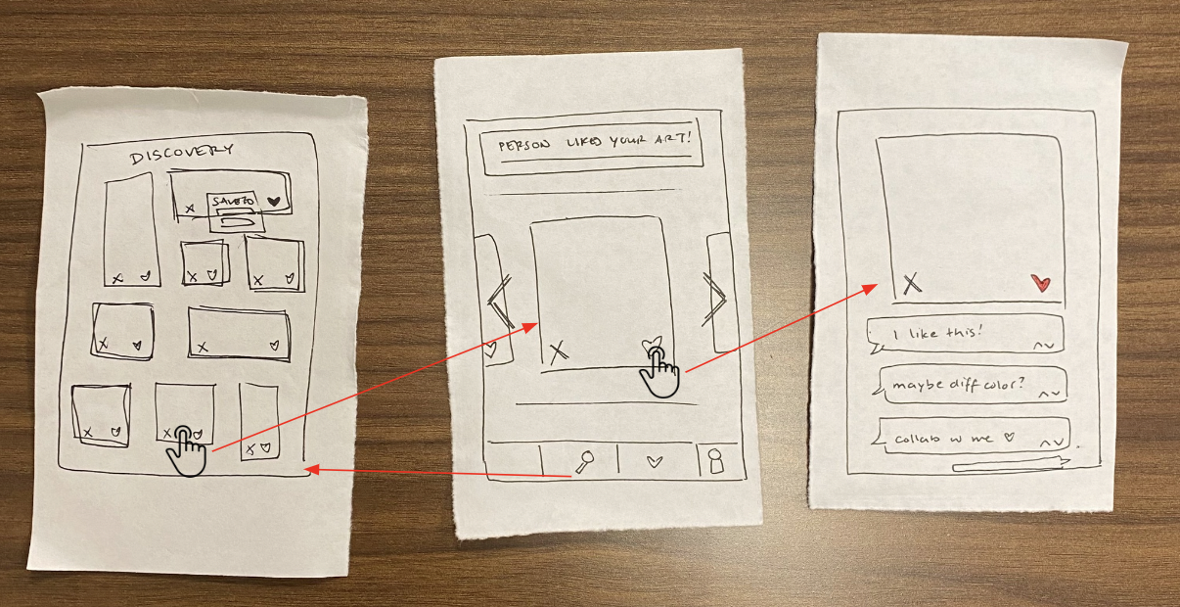

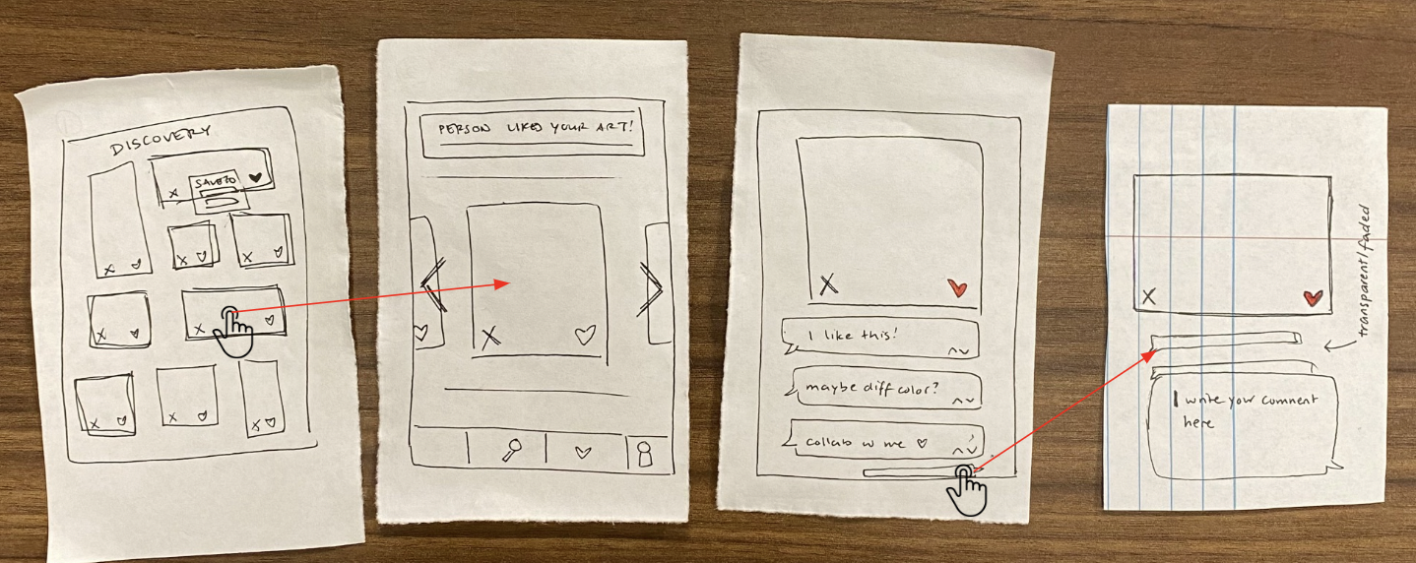
- Moderate Task: comment on a piece of artwork.
- Complex Task: schedule a meeting with another artist.
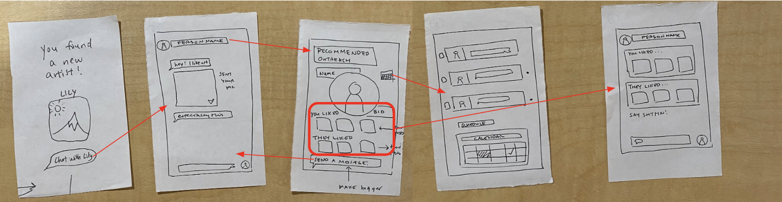

Usability Testing

For our usability testing, we took our physical lo-fi sketches out into the field and interviewed four artists we found around campus: Bri (photographer), Allan (writer), Ella (painter), and Willow (graphic designer). At least three team members were at each test, with one of us acting as the computer and controlling the paper screens, one acting as the facilitator, and one acting as the note-taker.

Evaluation Technique: Success of Usability Goals
We identified two usability goals that we wanted our prototype to achieve: we wanted our platform to be Learnable and Discoverable. For Learnable, we measured a user’s desire to engage with art on the homepage by counting the number of subtasks they were able to complete without facilitator intervention. For Discoverable, we measured a user’s willingness to interact with a matched artist by counting the number of connection-related features they were able to complete without facilitator intervention.

Learnable Task Chart
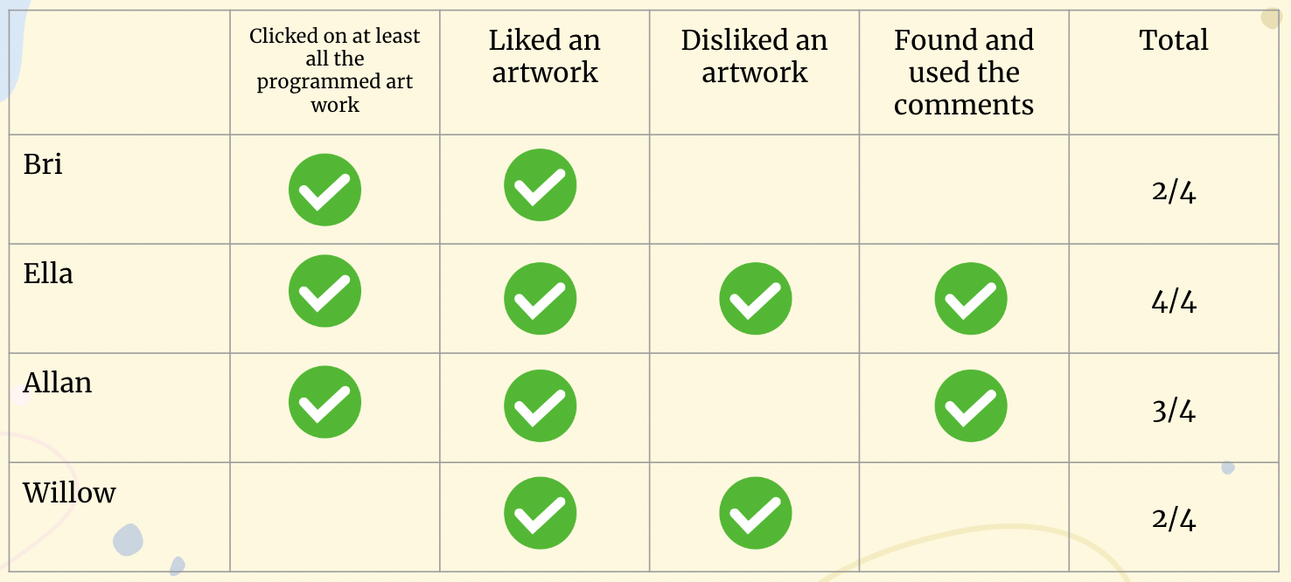

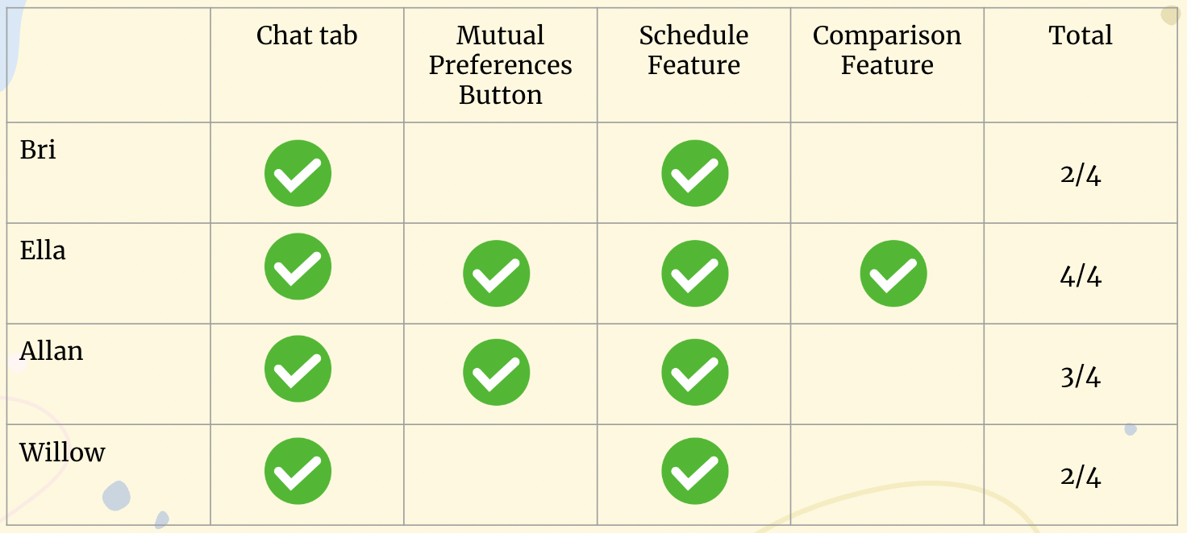
Discoverable Task Chart

We identified a few common positives and negatives that we observed across interviews. We had very positive reactions to our art-first anonymized approach and to our artist matching screen once the participant had liked enough posts to be matched. After being matched, participants were especially interested in interacting with the matched artist through the mutual preferences screen and scheduling screen. They enjoyed how our homepage was intuitive and familiar to popular platforms such as Pinterest.
On the flip side, participants also ran into a couple common problems:

- Two participants lost interest in exploring art before reaching the matching stage, getting distracted by other features such as the chat.
  - Participants didn’t realize the importance of liking/disliking art (it is necessary to unlock commenting and matching)
  - Bri and Allan did not dislike any artwork as they were worried the artist would see
- Too many interaction choices with matched user, participants lost interest before getting to all
  - Bri and Willow missed the mutual preferences button and comparison feature
- Scheduling page functionality was unclear – whose calendar are they viewing and how do they use it?
- Some icons were unclear, specifically the magnifying glass for homepage and checkmark for profile preferences

Thus, the big changes to be implemented in our med-fi prototype to address each of these commonly experienced issues were as follows:

- Funneling all user attention towards liking art, minimizing distractions to other features, to speed up matching process. Additionally, removing the option to dislike.
- Simplify avenues of interaction between matched artists
- Building out and clarifying the function of our scheduling page
- Implementing all suggested icon changes to clarify purpose

Med-Fi Prototype

We used Figma to implement our med-fi prototype.

- Simple Task: like a piece of artwork.
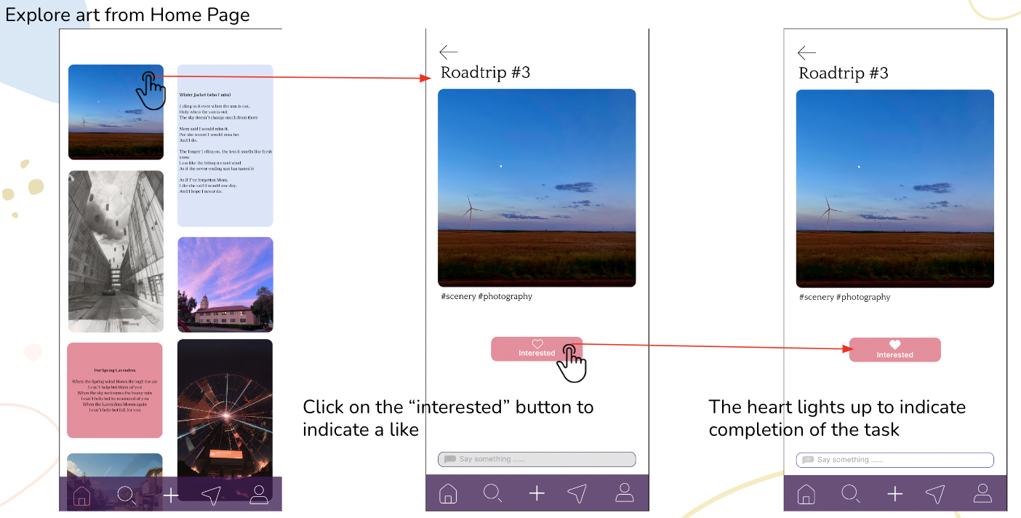

- Moderate Task: comment on a piece of artwork.
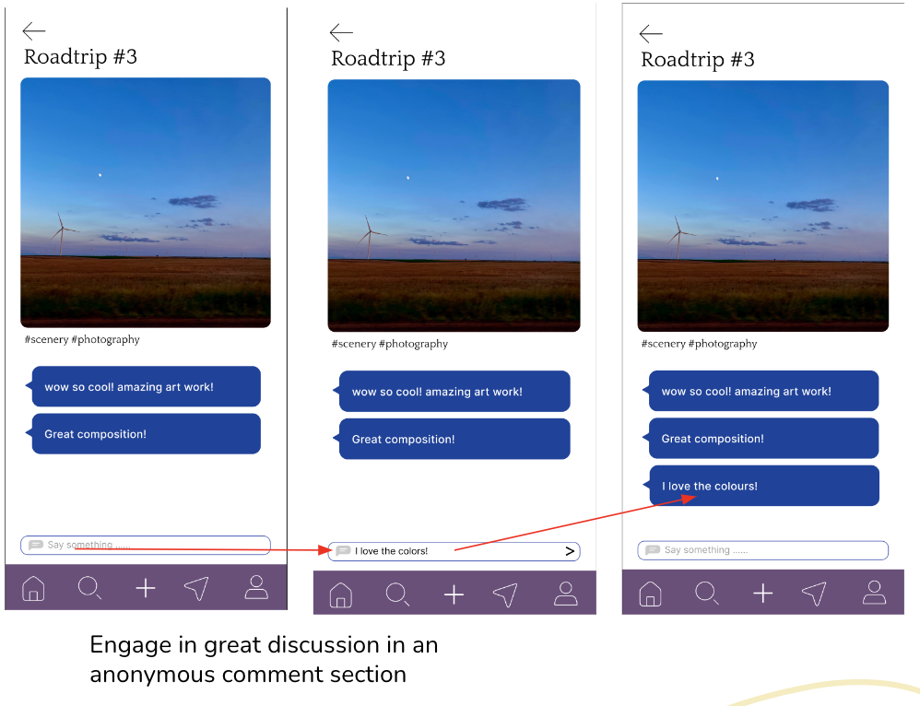

- Complex Task: schedule a meeting with another artist.

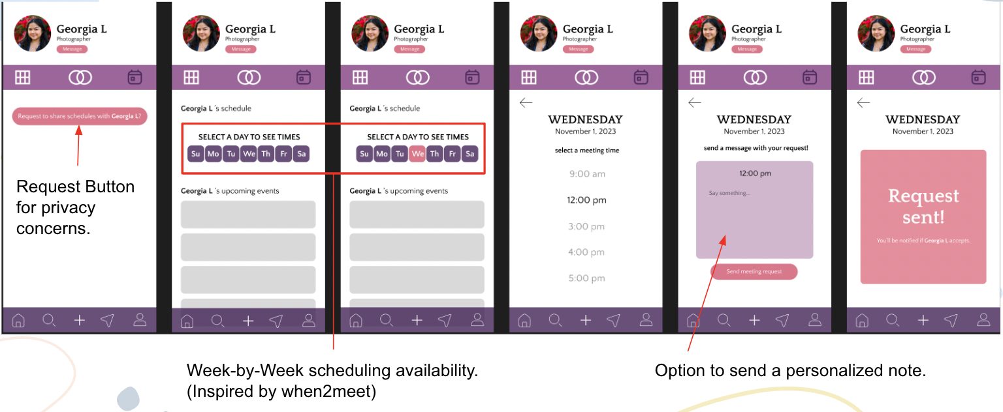

Heuristic Violation Analysis

We gave our med-fi prototype to another team within our CS 147 studio for a heuristic evaluation. Overall, we had 99 heuristic violations, with our top 2 categories of violations being H4: Consistency & Standards with 23 violations and H8: Aesthetic & Minimalist Design with 12 violations. Given the volume of our heuristic violations and our short timeline, we decided to focus on the severity 3 and 4 violations in most detail. Listed below are these violations plus the changes we implemented in our hi-fi prototype to address them.

Severity 3 Violations
- H5: No password confirmation box in registration
  - Added password confirmation box to prevent errors.
- H11: No alternative text for posts
  - Display title and caption in details of each post. No alternative text for the visually impaired was added due to the scope of the class, but we agree it will be necessary in the real world.
- H7: Lack of non-visual art
  - Not addressed: decided to focus on serving mainly visual artists.
- H3: No easy access to matched artist profiles
  - Plan to implement a button on a user’s profile that gives them access to the list of their matched artists.
- H4: No distinction between chat and recommended artists in the inbox
  - Plan to implement a list of not-yet-chatted matched artists in a user’s inbox.
- H4: Additional info does not appear on post during upload
  - Show additional info below the post.

We implemented a total of 6 changes as a result of these violations.

Severity 4 Violations
- H2: “Request to share schedules” button shows the other artist’s schedule
  - Removed the “request to share schedules” page and instead created a “request meeting” button in the inbox.
- H2: No way to upload non-visual art

We implemented a total of 1 change as a result of these violations.

Hi-Fi Prototype

- Simple Task: like a piece of artwork.
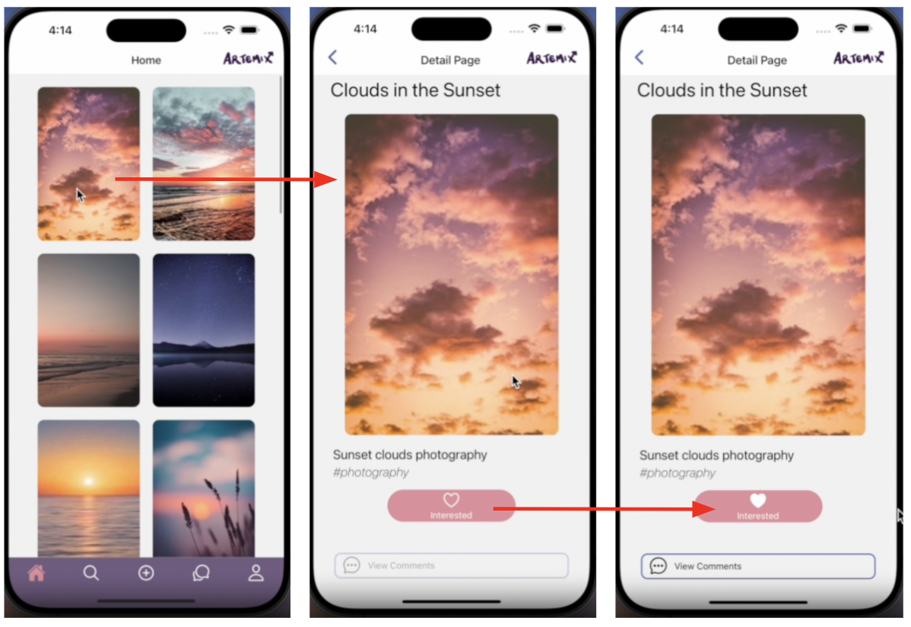

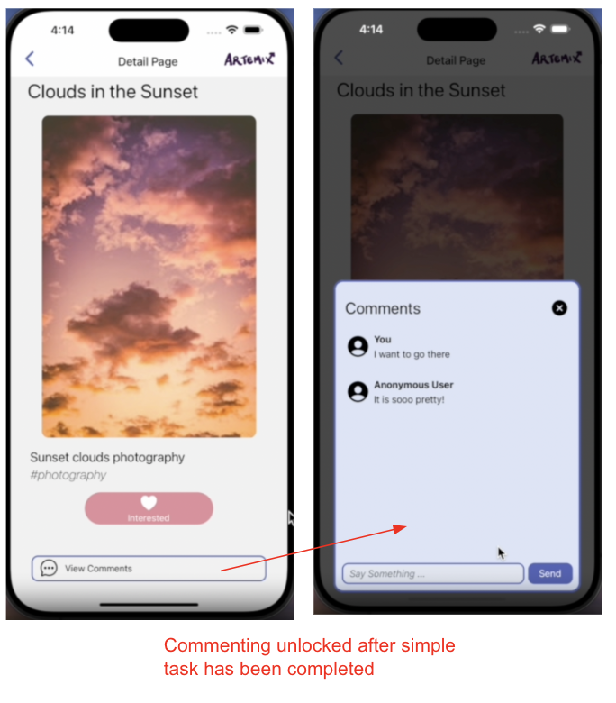
- Moderate Task: comment on a piece of artwork.

- Complex Task: schedule a meeting with another artist.
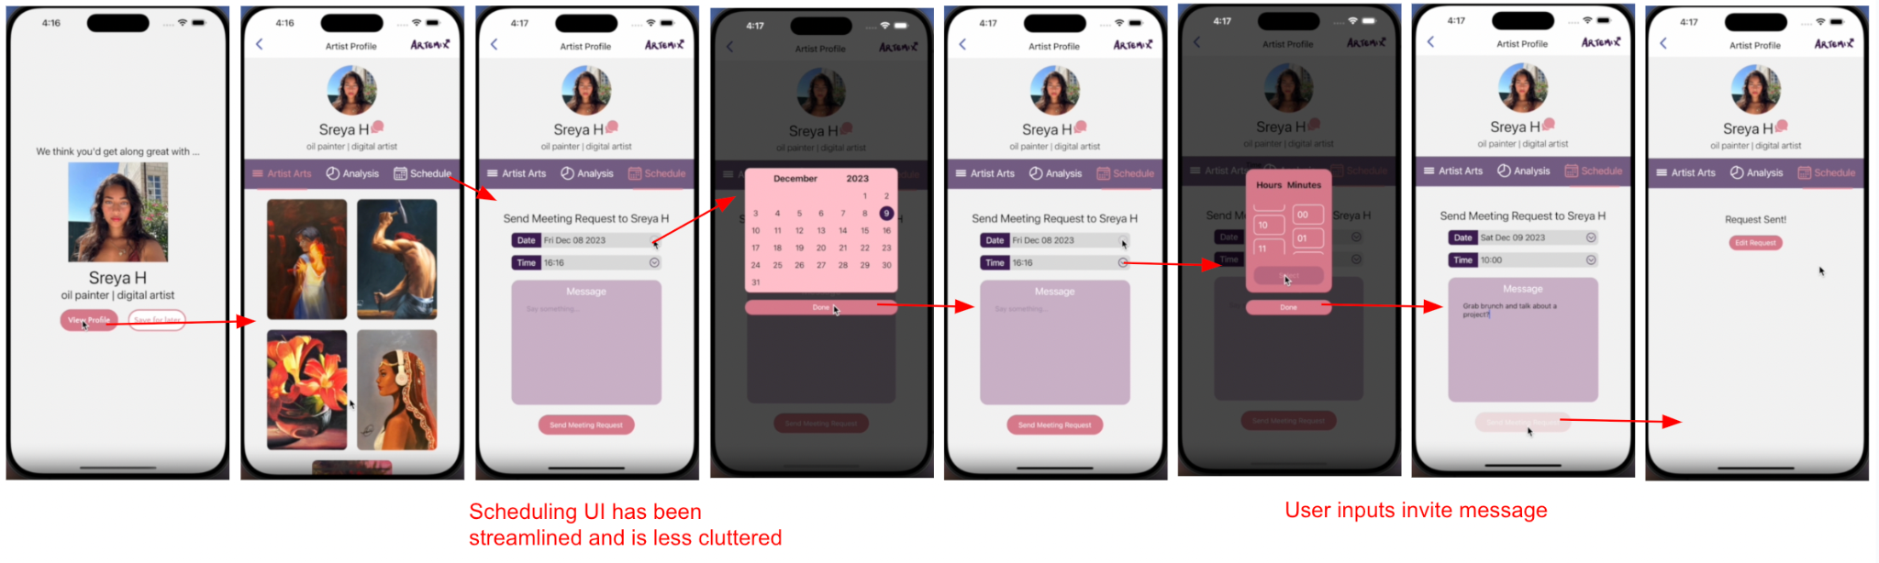

Values in Design

We focused on three core values throughout our design process for Artemix:

- Intentionality
Artists connect only with users who are familiar with and interested in their art. On Artemix, users are prompted to connect with an artist only after they've consistently shown interest in artworks through "likes", without prior knowledge of who the artist is.

- Flexibility & Autonomy
Empowers users with full control over their relationship with an artist they connect with, along with diverse options to explore further. Artemix includes features such as chat for direct communication, scheduling tools for potential online and offline meetups, and mutual preferences, allowing users to delve deeper into understanding each other.

- Intuitiveness
Make art easily accessible and exploratory, ensuring that connections to artists feel instinctive and seamless. Artemix’s homepage design should highlight the creative work and clicking on them should lead to a decluttered screen.

Additionally, when a user "likes" a piece, they are then shown more posts from that same creator, guiding them smoothly towards an artist recommendation.

Value Tensions

There exists a value tension between Intentionality and Autonomy: our goal to enhance connection quality through restrictions vs our goal to , as we imposed restrictions in order to maintain intentionality in our platform:

- User interaction on the app is restricted until they have connected to an artist.
- Users can explore countless arts but can't directly search for artists.
- Can’t join in comments discussion until they’ve indicated “like”.

However, we decided that protecting artist anonymity is essential and that these restrictions ensure artists connect based on an interest in arts, aligning with our main purpose.

Final Prototype Implementation

Tools used
We used React Native, Express.js, and MongoDB as our tools for our hi-fi prototype.

Pros | Cons
- MongoDB is easy and intuitive to  - React Native has lots of documentation and support, making developing easier | - MongoDB is not free/easy to deploy

Wizard of Oz techniques
We used the Wizard of Oz prototyping technique in 4 distinct places in our hi-fi prototype. The profile picture in the registration page, profile picture in our edit profile page, selected picture in our upload post page, and the meeting date and time in our scheduling page are all pre-decided and automatically filled in by the prototype.

Hard-coded techniques
All content on the app is hard-coded. All artwork is either personally sourced or found online, for the sake of variety. The comments seen are also hard-coded as the experience we’re trying to create for testing relies on a pre-existing community and interactions on the app. Lastly, the artist recommendation profile is also hard-coded with a fake bio and posts as prototypes generally require some level of pre-existing data for the sake of testing. Chats between the user and others on the app are also hard-coded and while messages can be sent, a message is never sent back. The uploading page is also hard-coded in the sense where it never updates in the backend and thus the user never sees it appear in their profile.

Reflection & Next Steps

Main Learnings

- Involve Real Users & Test Assumptions
Throughout the process of designing Artemix, our team came up with many assumptions that were then debunked or twisted through user interviews or experience prototypes, such as the assumption that rating commenter profiles would help artists take feedback better (debunked through our second experience prototype) or the assumption that all artists were looking for community (debunked through our needfinding interviews, which helped us focus less on performance artists and more on visual artists). We learned that getting into the field and talking to the people you hope to serve with your product is highly important in all stages of design, not just conception or in identifying pain points. Keeping in contact with your target users helps keep your project on track, and constantly touching base and continuing to user test throughout the process helped us keep Artemix as close to our initial goal as possible.

- Iterate, Iterate, Iterate
From the biggest to the smallest aspects of Artemix’s design and conception, every part of this project went through multiple phases and changes, from major to minor – whether it be switching up a couple icons for greater user clarity or completely shifting focus to a new or more specific user base (such as our transition from trying to serve all artists to serving more isolated artists to only serving visual artists), we learned that being open to change is a highly important part of the design process, as well as staying creative and constantly thinking outside of the box to get there. We learned not to marry ourselves to our first ideas – or our second, or our third.

- Get External Feedback
Almost all of our most useful and biggest changes came from addressing comments from external sources, such as the heuristic valuation analysis from our CS 147 studio or the user testing for our lo-fi prototypes. We learned that when you are too close to a project, you sometimes miss things that other people who are new to your idea or prototype may catch. Design cannot operate in a vacuum, and our final version of Artemix (at least for this class) was touched by many outside of the four of us.

Future Features

We had many ideas for Artemix features that, due to the timeline and scope of this class, could not feasibly come to fruition in our hi-fi prototype. Some are listed below:

- Video or audio posts
To serve wider communities of artists, we hoped to include the ability to post video (for artists such as choreographers, cinematographers, etc.) and audio (for musicians, singers, composers, etc.)

- Incorporation of location services
To increase likelihood of online connections going offline or connecting in person and strengthening the collaborative bond, we were inspired by dating apps to potentially include a location option for users to specify their desired geographical radius and only be shown art from users within that sphere.

- Event lists for community building
We initially hoped to include the ability for users to post artistic events for their matched artists to view and possibly attend.

